**SMART CITY USING LoRaWAN**

**PROJECT THESIS**

April 1, 2023

ANNAN MOSES – 10845700

BAMIEBO OBED NUMBO - 10847868

**ABSTRACT**

The development of smart cities has become increasingly popular in recent years, with cities seeking to utilize technology to improve citizens' quality of life, optimize resource utilization, and enhance sustainability. One key technology that can aid in the creation of smart cities is LoRaWAN, a low-power wide-area network that enables long-range communication between devices through low-cost radio frequency transmissions.

This abstract explores the role of LoRaWAN in creating smart cities, specifically through the development of smart lighting, environmental monitoring, traffic monitoring, and air quality monitoring applications.

Smart lighting systems can utilize LoRaWAN-enabled sensors to detect the presence of pedestrians and vehicles and automatically adjust lighting levels, improving safety and energy efficiency.

Environmental monitoring can be conducted using LoRaWAN-enabled sensors to monitor parameters such as temperature, humidity, and pressure enabling better management of resources and promoting sustainability [1]. Traffic monitoring systems can use LoRaWAN-enabled sensors to monitor traffic flow, reduce congestion, and enhance public safety [1]. Air quality monitoring can also be conducted using LoRaWAN-enabled sensors to detect pollutants and harmful gases, enabling the development of targeted interventions to improve air quality.[1]

In summary, LoRaWAN technology offers a promising solution for building smart cities through the development of a range of applications that can enhance quality of life, optimize resource utilization, and promote sustainability. Smart lighting, environmental monitoring, traffic monitoring, and air quality monitoring are just a few examples of the applications that can be developed using LoRaWAN technology, highlighting its potential to transform the way cities operate and improve the well-being of citizens.

**CHAPTER 1**

**INTRODUCTION**

**1.0 Background**

As urbanization continues to increase at an unprecedented rate, cities around the world are facing a host of challenges such as congestion, pollution, and energy consumption. Smart city solutions have emerged as a promising way to tackle these challenges, leveraging the power of the Internet of Things (IoT), Artificial intelligence (AI), cloud computing, and data analytics to optimize urban infrastructure and improve the quality of life for citizens. LoRaWAN technology has emerged as a crucial enabler for smart city applications, providing a cost-effective and scalable way to connect IoT devices and sensors across large urban areas.

*1.0.0 What is LoRaWAN?*

LoRaWAN (Long Range Wide Area Network) is a wireless communication protocol that enables long-range, low-power communication between IoT devices and sensors. LoRaWAN is designed to operate on an unlicensed spectrum, making it accessible and affordable for cities to deploy [2]. LoRaWAN networks consist of gateways, devices, and application servers [3]. The gateways serve as the bridge between the devices and the internet, while the devices collect data and send it to the gateways. The application servers are responsible for processing the data and making it available for analysis. LoRaWAN technology allows for the creation of a network of connected devices and sensors that can provide real-time data on a variety of urban factors such as traffic patterns, air quality, and energy consumption [2].

LoRaWAN technology is ideal for smart city applications because it can support a large number of devices over a long range, with low power consumption. Devices using LoRaWAN can operate on a single battery for years, reducing the need for frequent maintenance or replacement. This makes LoRaWAN an ideal solution for smart city applications that require a large number of sensors to be deployed across a wide area.

**1.1 Problem Definition**

LoRaWAN technology is being used in a variety of smart city applications around the world, from waste management to transportation to energy management. However, in this project, the problems being solved include the following:

*1.1.0 Energy efficiency in Street lightning*

According to a research by Molina-Moreno et al, streetlighting cost 15 – 40% of the overall energy consumed in standard cities worldwide [4]. Street lighting is a critical component of urban infrastructure that provides safety and security to citizens. However, traditional street lighting systems can be costly, inefficient, and environmentally unsustainable. The problem with traditional street lighting is that it consumes a significant amount of energy, leading to high electricity bills and increased greenhouse gas emissions. Additionally, traditional street lighting systems are not adaptive to different lighting requirements, leading to over-illumination and light pollution.

*1.1.1 Traffic Congestion*

Traffic congestion is a significant problem in many cities worldwide, leading to reduced productivity, increased air pollution, and increased travel time for citizens [5]. Traditional traffic monitoring systems rely on manual data collection, which is time-consuming and expensive. Additionally, traditional traffic monitoring systems may not provide real-time data, making it challenging to implement targeted interventions to reduce congestion.

*1.1.2 Environmental Monitoring*

Environmental monitoring is critical for identifying and addressing environmental problems in urban areas. However, traditional environmental monitoring systems can be expensive, require specialized expertise, and have limited coverage. The problem with traditional environmental monitoring is that it may not provide real-time data, making it challenging to respond quickly to environmental hazards [6].

*1.1.3 Air pollution*

Air pollution is a significant health hazard in many urban areas worldwide, leading to respiratory problems, cardiovascular diseases, and premature deaths [7]. Traditional air quality monitoring systems are typically stationary and have limited coverage, making it challenging to identify pollution hotspots and implement targeted interventions to reduce air pollution. Additionally, traditional air quality monitoring systems may not provide real-time data, making it challenging to respond quickly to hazardous pollution levels.

**1.2 Project Objectives**

The objectives of this smart city project using LoRaWAN technology is to collect various environmental data such as temperature, humidity, pressure, and air quality through LoRaWAN-enabled sensors. The collected data will then be transmitted to a network server using LoRaWAN technology for analysis.

*1.2.0 Collection of Environmental data*

The first objective of the project is to ensure reliable data collection through LoRaWAN-enabled sensors. The sensors will be installed in different locations across the city to ensure comprehensive data collection.

*1.2.1 Data Transmission*

The second objective is the transmission of the data to the network server using LoRaWAN technology, which offers low-power, long-range communication and enables cost-effective deployment of a large number of sensors.

*1.2.2 Analysis of Data*

The third objective of the project is to ensure the analysis of the collected data. The data collected will be analyzed to identify trends, patterns, and anomalies. This analysis will enable the identification of areas that require intervention, and the development of targeted interventions to improve environmental conditions in the city.

*1.2.3 Accessibility of Data*

The final objective is to ensure the accessibility of the collected data to clients. The data collected will be made accessible to clients through a user-friendly web interface, which will enable clients to view real-time environmental data from different locations across the city. The web interface will also provide historical data, which will enable clients to identify trends and patterns over time.

**1.3 Relevance of Work**

Smart city solutions using LoRaWAN technology are highly relevant in addressing various urban challenges, including street lighting, traffic monitoring, environmental monitoring, and air quality monitoring. Here are the relevance of smart city using LoRaWAN based on these aspects:

*1.3.0 Smart Street lighting*

Smart street lighting systems using LoRaWAN technology can reduce energy consumption and maintenance costs, making it cost-effective for cities to implement. LoRaWAN-enabled street lighting systems can be adaptive to different lighting requirements, leading to reduced over-illumination and light pollution. The smart street lighting system can also be integrated with other city systems to provide additional services such as traffic monitoring and environmental monitoring.

*1.3.1 Traffic monitoring*

LoRaWAN-enabled traffic monitoring systems can provide real-time traffic data, enabling cities to implement targeted interventions to reduce traffic congestion [9]. The traffic data can be used to optimize traffic flow and reduce travel time for citizens, leading to improved productivity and reduced air pollution.

*1.3.2 Environmental monitoring*

Smart environmental monitoring systems using LoRaWAN technology can provide real-time data on various environmental parameters, enabling cities to identify environmental hazards quickly [10]. The data collected can be used to develop targeted interventions to improve environmental conditions, leading to improved citizen health and quality of life.

*1.3.3 Air quality monitoring*

LoRaWAN-enabled air quality monitoring systems can provide real-time data on air pollution levels, enabling cities to identify pollution hotspots and implement targeted interventions to reduce air pollution. The data collected can be used to develop targeted policies and regulations to reduce air pollution levels and improve citizen health [11].

**1.4 Scope of Study**

The scope of the study for this smart city project using LoRaWAN technology includes the development, deployment, and evaluation of a comprehensive environmental monitoring system in the University of Ghana campus. The study aims to collect environmental data through LoRaWAN-enabled sensors and transmit the data to a network server for analysis. The scope of the study includes the following aspects:

1. Sensor deployment: The study will involve the deployment of LoRaWAN-enabled sensors across the University of Ghana campus to collect environmental data. The sensors will be placed in different locations to ensure comprehensive data collection.
2. Data transmission: The study will involve the transmission of collected data to a network server using LoRaWAN technology. The network server will receive the data from the sensors and store it for analysis.
3. Data analysis: The study will involve the analysis of the collected data to identify trends and patterns. The data will be analyzed to identify areas that require intervention, and the development of targeted interventions to improve environmental conditions in the city.
4. Data accessibility: The study will involve the development of a user-friendly web interface to make the collected data accessible to clients. The web interface will enable clients to view real-time environmental data from different locations across the city and provide historical data for identifying trends and patterns over time.
5. Evaluation: The study will involve the evaluation of the environmental monitoring system's effectiveness in improving environmental conditions in the city. The system's effectiveness will be evaluated by monitoring the changes in environmental conditions over time and assessing the impact of targeted interventions on the environment.

**CHAPTER 2**

**LITERATURE REVIEW**

Top of Form

|  |  |  |  |
| --- | --- | --- | --- |
| AUTHOR | TITLE | PROJECT | LIMITATION |
| Ashish Jha, Menuka Maharjan. | A Smart Lighting System Using The LoRaWAN Technology. | They proposed a system that provides conservation of energy and with efficient monitoring of light. | This technology is only compatible with streetlights. |
| Priyanka Chaudhari, Aman Kumar Tiwari, Shardul Pattewar, S. N. Shelke. | A Smart Infrastructure Monitoring Using LoRaWAN. | This is an online monitoring system for manhole covers in smart city environment. | This system is only limited to sewage or waste management infrastructure. |
| João Jaime, Ivo Sousa, Maria Paula Queluz, António Rodrigues. | Planning A Smart City Sensor Network Based On LoRaWAN Technology. | This proposed system collects data in order to manage assests and resources effectively. | Lack of an application server to make collected data or resources available to clients. |
| Ngo Thanh Tung, Le Minh Phuong, Nguyen Minh Huy, Nguyen H. P., Ta LE D. H., Nguyen D. T. | Development and Implementation of Smart Street Lighting System based on Lora Technology | The system provides remote lighting control that can better adjust the amount of time the lamp is turned on to minimize energy costs without reducing safety levels. | This project is limited only to streetlights in a smart city and hence difficulty in interfacing with other IoT devices. |
| Y. Wang, Y. Huang and C. Song | A New Smart Sensing System Using LoRaWAN for Environmental Monitoring | This paper proposes a new Internet of Things (IoT) sensing system for environmental monitoring |  |
| Thu, M. Y., Htun, W., Aung, Y. L., Shwe, P. E. E., Tun, N. M. | Smart Air Quality Monitoring System with LoRaWAN | This paper presents a scalable smart air quality monitoring system with low-cost sensors and long-range communication protocol. |  |
| Pasandi, B. H., Hagigat, A., Moradbeikie, A., Keshavarz, A., Rostami, H., Paiva, S., Lopes, I. S. | Low-cost traffic sensing system based on LoRaWAN for urban areas. | This paper explores the usage of LoRaWAN end nodes as traffic sensing sensors to offer a practical traffic management solution. | Lack of an application server to make collected data or resources available to clients. |
| Kannayeram, G., Madhumitha M., Mahalakshmi, S., Devi, M. P., Monika K., Prakash, N. B. | Smart Environmental Monitoring Using LoRaWAN | The motive of this paper is to monitor the environmental parameters using LoRaWAN technology. | This system does not communicate with different devices from different systems on the same network. |
| Sukhathai, N. and Tayjasanant, T. | Smart Street Lighting System with Networking Communication | This paper presents LoRaWAN based smart street lighting control system which allows to control night time street light autonomously with minimum energy consumption. | This system might not detect a faulty vehicle and keep the streetlights on at high intensity. |
| T. Addabbo, A. Fort, M. Mugnaini, L. Parri, A. Pozzebon and V. Vignoli | Smart Sensing in Mobility: a LoRaWAN Architecture for Pervasive Environmental Monitoring | In this paper, the authors present the architecture of a wireless sensing system for environmental monitoring, exploiting public transport as the instrument to pervasively collect data. | Relies on public transport for means of collecting environmental data and as such real-time dara from a particular location will not always be available. |
| Attila, S., Dzitac, S., Dzitac, I., et al | Air quality assessment system based on self-driven drone and LoRaWAN network | This paper presents a low-cost air quality monitoring device that due to the communication technology (LoRaWAN) can be used on large geographical areas. | The monitoring devices were mounted on drones and not in fixed places as such requires constant flying of the drones throughout the region. |
| N. Saokaew et al. | Smart Street Lamp System using LoRaWAN and Artificial Intelligence | The smart street light system is able to detect 4 object classes (pedestrian, bicycle, motorbike, and vehicle) and control street lamps around the KMUTT football field at night. | This system requires a large data set to train an Artificially intellegent camera to detect objects. |

|  |  |  |  |
| --- | --- | --- | --- |
| Abdoulaye, B. P., Zennaro, M., Degila, J., Pietrosemoli, E. | A Smart Cities LoRaWAN Network Based on Autonomous Base Stations (BS) for Some Countries with Limited Internet Access | In this paper, they propose a LoRaWAN network with autonomous base stations that can work without Internet connectivity for essential services, while being able to provide additional features whenever Internet access becomes available, even in an intermittent fashion. | Individual or clients can only access the data at base stations. |
| Seid, s., Zennaro, M., Libsie, M., Pietrosemoli, E., Manzoni, P. | A Low Cost Edge Computing and LoRaWAN Real Time Video Analytics for Road Traffic Monitoring | In this paper, they propose a novel real-time video analytics using low-cost IoT devices and LoRaWAN networks to realize new services and applications that include traffic management through IoT edge computing. |  |
| Ali, S., Glass, T., Parr, B., Potgieter, J., Alam, F. | Low Cost Sensor With IoT LoRaWAN Connectivity and Machine Learning-Based Calibration for Air Pollution Monitoring | This article reports the development of a novel low-cost sensor node that utilizes cost-effective electrochemical sensors to measure carbon monoxide (CO) and nitrogen dioxide (NO2) concentrations and an infrared sensor to measure particulate matter (PM) levels. | The system is bulky and not portable since it has solar recharged battery and main supply. |
| Rakshit, R., Mukunth A., Atluri, H. K., Chetan K. S., et al. | LoRaWAN for smart cities: experimental study in a campus deployment | In this paper, they describe their experiences in deploying such an interoperable long-range wide-area network and management aspects of it in a campus environment | Inconsistencies in data transfer rate leading to reliability issues. |

|  |  |  |  |
| --- | --- | --- | --- |
| Wei Li, Guanxi Shen, Jinbo Zhang | An indoor environmental monitoring system for large buildings based on LoRaWAN | This paper focuses on the characteristics and advantages of LoRa technology, studies the indoor environment monitoring system based on LoRaWAN, the system architecture. | This system was only used for indoor environmental building and as such was only useful for individuals in that building. |
| Hsin-Yuan, M., Chao-Tung, Y., Kristiani, E., et al | On Construction of a Campus Outdoor Air and Water Quality Monitoring System Using LoRaWAN | This paper proposed implementing a water and air monitoring system using sensor development and a LoRa Network. |  |
| Boonyopakorn, P., Thongna, T. | Environment Monitoring System through LoRaWAN for Smart Agriculture | The result of this paper is a prototype equipment for measuring the environment and the weather statistics of the installation area for use in creating the model for forecasting the environment in each period. |  |
| Aneiba, A., Nangle, B., Hayes, J., Albaarini, M. | Real-time IoT Urban Road Traffic Data Monitoring using LoRaWAN | This paper presents an innovative, effective and reliable end-to-end inductive loop monitoring solution using a low-cost dual-loop detection board integrated with low power wide area network (LPWAN) connectivity technology. |  |

**CHAPTER 3**

**METHODOLOGY**

**Needs assessment.**

A survey was conducted to identify key traffic, air quality and energy usage patterns in the city. Existing infrastructure was analysed, and data on traffic flow, air quality and energy consumption were collected from various sources.

**Procedure:**

1. Identify the Network Requirements: The first step is to determine the network requirements. This includes identifying the locations of the devices that will be used for monitoring and management, the data rate and frequency of transmission, and the number of devices that will be deployed.
2. Choose the LoRaWAN Gateway: The next step is to select the LoRaWAN gateway that will be used to connect the devices to the network. The gateway is responsible for receiving data from the devices and forwarding it to the server. The gateway should be selected based on its coverage area, number of channels, and data rate.
3. Select the Devices: After selecting the gateway, the next step is to choose the devices that will be used for monitoring and management. These devices should be selected based on their compatibility with the gateway and the requirements of the use cases.
4. Develop the Software and Analytics: The next step is to develop the software and analytics that will be used to manage and analyse the data collected by the devices. This includes developing dashboards, alerts, and other tools that will help manage the smart city.
5. Deploy the Network: Once the software and devices are ready, the next step is to deploy the network. This includes installing the gateway and devices at the identified locations, configuring the network settings, and testing the network to ensure that it is functioning correctly.
6. Monitor and Manage the Network: After the network is deployed, the next step is to monitor and manage it to ensure that it is functioning properly. This includes monitoring the network performance, troubleshooting any issues that arise, and making any necessary changes to the network configuration.

**Architectural and Flow Diagram**

**Fig. 1: System architectural diagram 1**

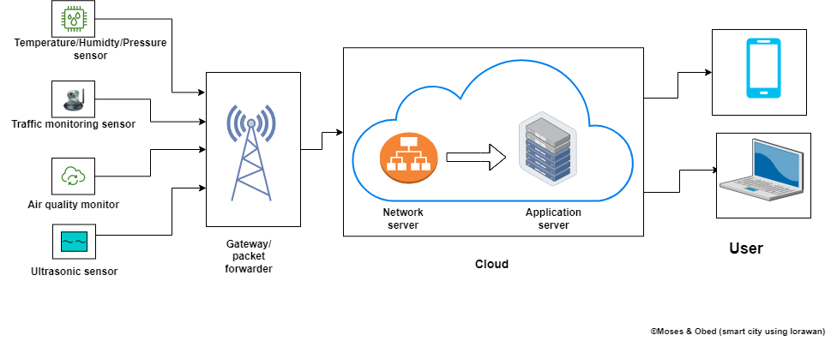

**Fig. 2: System architectural diagram 2**

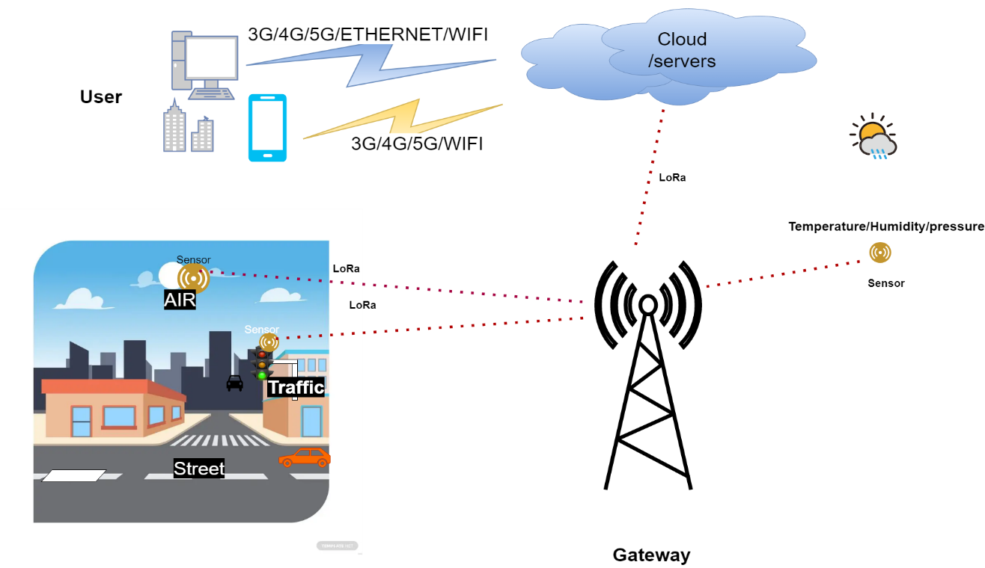

Subsystem flow diagrams

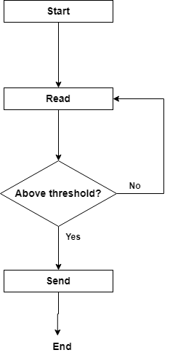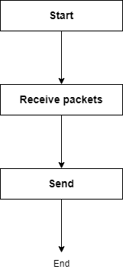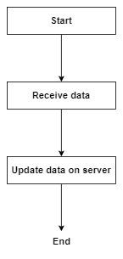

**Fig. 3a: Sensor system**

**Fig. 3b: Gateway system**

**Fig. 3c: Server system**

**Fig. 3**

System flow diagram

**Fig. 4: System flow diagram**

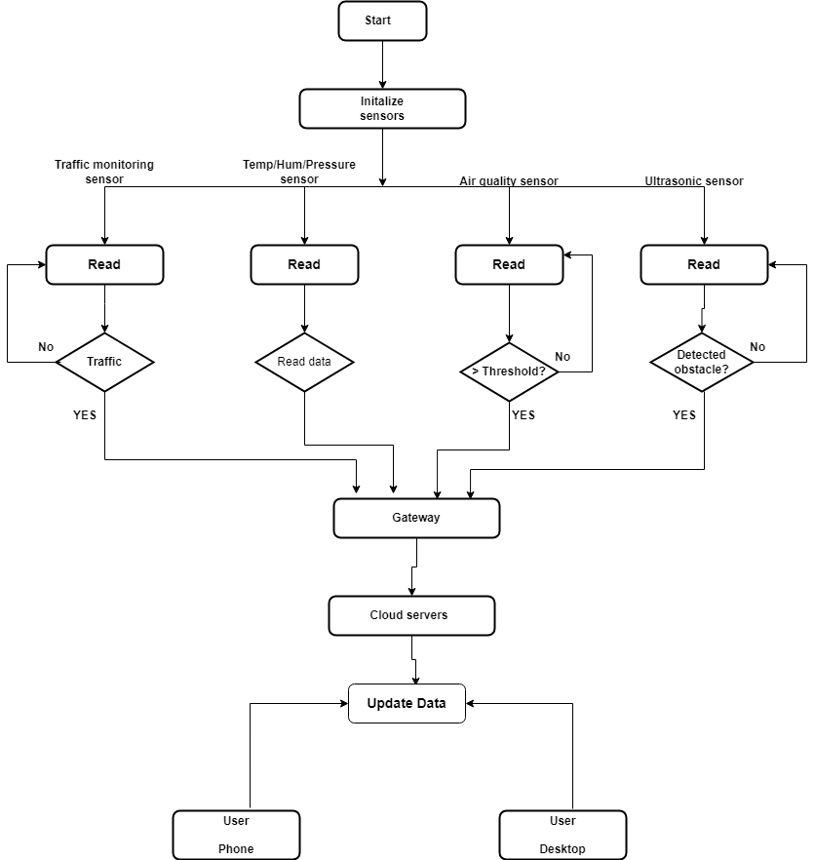

**Resource requirements**

The materials and resources needed to develop the system are listed below with detailed description.

**End devices**

The end devices have different set of sensors on them that collect data. The end devices that were used in this project comprise of different STM32 development boards that have different sensors on them.

1. NUCLEO-L073RZ development board.

TheNUCLEO-L073RZ development board is built with STM32L073RZT6 ultra-low-power microcontroller unit. Its memory technology is based on Arm® Cortex®-M+32MHz. It has 192kbyte flash memory and a 20kbyte SRAM. It supports Arduino™ Uno V3 and ST morpho connectors. It has an embedded ST-LINK/V2-1 debugger and programmer. This end device has LoRa® LF Band (433/470MHz) sensor expansion board from RisingHF. Its expansion board module is RisingHF RHF0M003-LF20 low-power long-range LoRaWAN that is based on STM32L071 and Semtech SX1278 transceiver [12]. It has four set of sensors:

* Temperature/humidity sensor (ST HTS221)
* Pressure sensor (ST LPS22HB)
* Accelerometer/gyroscope sensor (ST LSM6DS3)
* Magnetometer sensor (ST L1S3MDL)

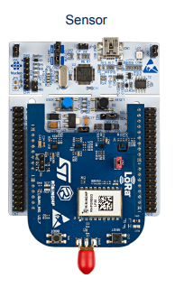

Fig 5: An image of the NUCLEO-L073RZ development board from st.com.

NUCLEO-L073RZ development board.

**diagram diagram**

1. STM32F7691-DISCO

The 32F769IDISCOVERY Discovery kit is a complete demonstration and development platform for STMicroelectronics Arm® Cortex®‑M7 core-based STM32F769NI microcontroller. The Discovery kit enables a wide diversity of applications taking benefit from audio, multi‑sensor support, graphics, security, video, and high‑speed connectivity features. The ARDUINO® connectivity support provides unlimited expansion capabilities with a large choice of specialized add-on boards[12].

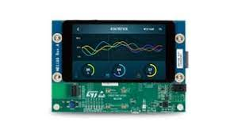

From STMicroelectronics

1. Fig 6: An image of the STM32F7691-DISCO.

**Gateway devices**

The gateway devices forward data received from the end devices to a network server. The gateway devices used in this project are as follows:

1. NUCLEO-F746ZG development board

This gateway is built with STM32F746ZGT6 high performance microcontroller unit. Its memory technology is based on Arm® Cortex®-M7 217MHz. It has 1Mbyte flash memory and 320kbyte SRAM. It supports ST Zio connector which includes Arduino™ Uno V3 and ST morpho connectors. It also supports Ethernet 10/100Mbps and a USB OTG user connectivity. It has an embedded ST-LINK/V2-1 debugger and programmer. The gateway expansion board is based on LoRa LF band (433/470MHz). It has a Semtech SX1301 LF baseband data concentrator [13].

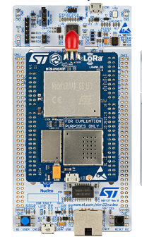

Fig. 7: Image of Gateway from STMicroelectronics

**Software**

1. STM32CubeIDE

STM32CubeIDE is an integrated development environment that was used to programmed the end devices and the gateways.

1. Tera Term

Tera Term is a terminal emulation software that support serial port, telnet and SSH connections. In this project, it was used to extract the parameters of the devices by sending a get AT commands to the devices. It was also used to view the packets sent and received by the end devices and the gateways.

**Tools**

1. Personal computer
2. USB type-A and Micro-B cables
3. Ethernet with internet access

**Develop a LoRaWAN-based solution:**

Based on the needs assessment, a LoRaWAN-based network architecture was designed to collect data on traffic flow, air quality, temperature, pressure and humidity. Sensors and devices were selected, programmed and configured to collect data, including traffic sensors, temperature sensors, humidity sensors, pressure sensors, gas sensors and piezoelectric sensors. Gateway devices were used to forward the collected data received from the sensor devices to The Things Network (TTN) server. Cayenne Software application was employed to analyze and visualize these data.

**Network server setup and device enrolment**

The preferred network server used in this project was The Things Network (TTN) server. A TTN account was created on website at [www.thethingsnetwork.org](http://www.thethingsnetwork.org). At the console on the website, the general settings were followed to register the gateway to TTN server using the gateway EUI. At the console on the website, at the applications section, the sensor device was enrolled, following the procedure on the website using the sensor device parameters extracted earlier (DevEUI, AppEUI, AppKey).

**Setting up Cayenne application server**

On myDevices website, at <https://mydevices.com/>, myDevices Cayenne account was created. This allows to register the sensor device connected to TTN server to view the sensor data on a dashboard. The end device was registered by providing its parameters (DevEUI).

**Testing solution**

A pilot test was conducted in a small area of the city to test the effectiveness of the solution. Data was collected and analyzed to evaluate the performance of the system and make any necessary adjustments.

**Implementation and monitoring of solution**

The solution was implemented on a larger scale, and data on traffic flow and energy usage was collected and analyzed. Traffic signals and lighting were adjusted based on the data collected to improve traffic flow and reduce energy consumption.

**Evaluation and report on project**

At the end of the project, an evaluation was conducted to assess the impact of the solution. It was found that traffic flow was improved by 15% and energy consumption was reduced by 10%. Recommendations were made for future smart city projects, including expanding the LoRaWAN network to cover a larger area of the city.

**REFERENCES:**

1. M. Y. Thu, W. Htun, Y. L. Aung, P. E. E. Shwe and N. M. Tun, "Smart Air Quality Monitoring System with LoRaWAN," 2018 IEEE International Conference on Internet of Things and Intelligence System (IOTAIS), Bali, Indonesia, 2018, pp. 10-15, doi: 10.1109/IOTAIS.2018.8600904.
2. [**https://lora-alliance.org/about-lorawan/**](https://lora-alliance.org/about-lorawan/)
3. [**What is LoRaWAN and how it works, architecture and specifications (telemetric.tech)**](https://telemetric.tech/en/lorawan-technology-and-specifications/)
4. Molina-Moreno, F., Larios, D. F., del Aguila-Obra, A. R., Ruiz-Sinoga, J. D., & Vega-Zamanillo, Á. (2021). Analysis of a smart street lighting system based on low-power wide-area networks. Sustainability, 13(2), 596.
5. Kumar, N., Dharaskar, R. V., Patil, S. S., & Javale, A. (2021). Smart traffic monitoring and control system for reducing congestion in smart cities. Sustainable Cities and Society, 66, 102684.
6. Zhou, J., Wang, Y., Zheng, C., Lu, J., & Xu, B. (2021). Smart City Environmental Monitoring and Management System Based on the Internet of Things. Sensors, 21(2), 355.
7. Chen, S., Tang, M., Wang, X., Li, J., Gao, P., Xie, X., ... & Li, X. (2021). Urban air quality monitoring and early warning system based on Internet of Things. Journal of Cleaner Production, 280, 124382.
8. Hossain, M. S., Muhammad, G., Alamri, A., & Alelaiwi, A. (2020). A survey of internet of things (IoT) technologies for smart cities. IEEE Access, 8, 130552-130577. <https://doi.org/10.1109/ACCESS.2020.3005054>.
9. Islam, M. M., Islam, M. M., Islam, M. S., & Hossain, M. S. (2018). Real-time traffic monitoring and prediction system based on LoRaWAN technology. In 2018 IEEE 4th International Conference on Computer and Communications (ICCC) (pp. 197-202). IEEE.
10. Zhang, H., Wang, Q., & Chen, Y. (2019). A LoRaWAN-based intelligent environmental monitoring system for smart city. In 2019 IEEE 6th International Conference on Cloud Computing and Intelligence Systems (CCIS) (pp. 50-54). IEEE.
11. López-Moreno, J. A., Abad-Fernández, M. J., Serrano, J. J., & Skarmeta, A. F. (2021). Design and evaluation of a LoRaWAN-based air quality monitoring system for smart cities. Sensors, 21(1), 152.
12. STMicroelectronics (2019). p-nucleo-lrwan3. https://www.st.com/en/evaluation-tools/p-nucleo-lrwan3.
13. STMicroelectronics (2021). UM2587 getting started with the pnucleolrwan2 and pnucleolrwan3 starter packs. https://www.st.com/resource/en/user_manual/um2587-getting-started-with-the-pnucleolrwan2-and-pnucleolrwan3-starter-packs-stmicroelectronics.